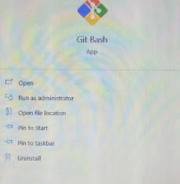

**Screenshot 3.2.1**

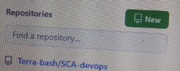

**Screenshot 3.2.2**

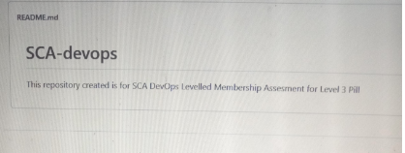

**Screenshot 3.2.3**



**Screenshot 3.2.4**

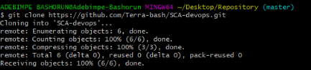

**Screenshot 3.2.5**



**Screenshot 3.2.6**



**Screenshot 3.2.7**



**Screenshot 3.2.8(1)**

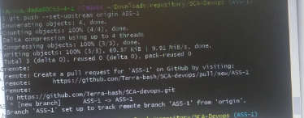

**Screenshot 3.2.8(2)**

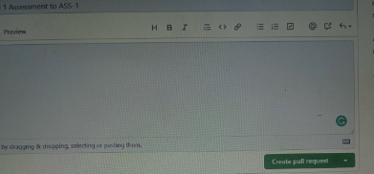

**Screenshot 3.2.9**

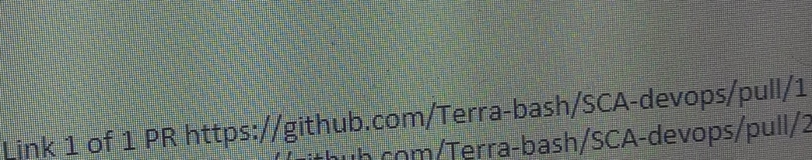

**Screenshot 3.2.10**

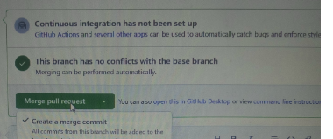

**Screenshot 3.2.11**

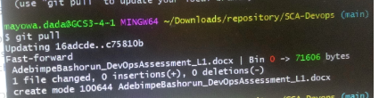

**Screenshot 3.2.12**



**Screenshot 3.2.13**



**Screenshot 3.2.14**

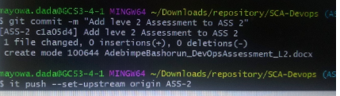

**Screenshot 3.2.15(1)**



**Screenshot 3.2.15(2)**

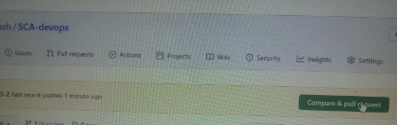

**Screenshot 3.2.16**



**Screenshot 3.2.17**

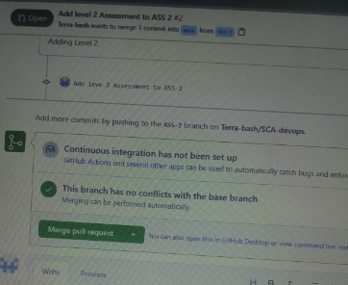

**Screenshot 3.2.18**